HEALTH CARE ANALYTICS & PATIENT CARE
INSIGHTS

PROJECT OVERVIEW:
- The main objective of this project is to analyse patient health data using Power BI and to build an interactive dashboard that helps to understand the health condition of patients clearly. In the present healthcare system, a large amount of patient data is collected daily, such as age, gender, ethnicity, medical condition, systolic and diastolic blood pressure. But without proper analysis, this data is not useful for decision making. This project converts that raw data into meaningful insights through data cleaning, data modelling, DAX calculations and data visualization.
- The dashboard mainly focuses on analysing blood pressure levels across different patient groups. Systolic and Diastolic blood pressure are the key indicators of heart health. By analysing these values based on gender, ethnicity and medical condition, we can identify which group of patients are at high risk. For example, patients with Chronic Kidney Disease show very high average systolic values compared to patients with Asthma and Back Pain. This kind of insight helps doctors and hospital management to take early precautions and to give special attention to high-risk patient.
DATA SOURCE:
- Source Description:
https://huggingface.co/datasets/mdsajjadullah/synthetic-medical-ehr-dataset/tree/main

- Domain: Health Care Analytics & Patient Care Insights
PROBLEM STATEMENT:
- To improve healthcare data quality through systematic data cleaning and transformation using Microsoft Excel ,followed by developing above problems, this project proposes a Patient Health Analysis Dashboard using Microsoft Excel for data cleaning and Power BI for visualization. First, the raw dataset full_dataset.csv is cleaned in Excel. Duplicates are removed, missing values are handled, data types are corrected and formats are standardized. After cleaning, the data is imported into Power BI.
- In Power BI, the data is modelled into three tables - Dim_Patient, Dim_Condition and Fact_Health using Star Schema. Relationships are created between the tables. DAX measures like Average Systolic, Average Diastolic and Total Patients are created for accurate calculations. Finally, an interactive dashboard is created with Donut Chart, Bar Charts and Cards. The dashboard allows the user to filter data by gender, ethnicity and condition and to identify high-risk patients in one click. This system saves time, reduces manual error and helps doctors to take fast and correct decisions.
ATTRIBUTE COLUMN:
S.No | Attribute | Data Type | Description | Cleaning Done
1 | patient_id | Text | Unique ID-P-XXXX | Duplicate Removed
2 | age_midpoint | Number | Middle age of Range | Null Checked
3 | Gender | Text | Female/Male /Non-binary | Standarrized
4 | Ethnicity | Text | White,Hispanic,Black,Asian, | Spelling Corrected
5 | Region | Text | West,Central,South,East,North | Standarized
6 | icd10_code | Text | Disease Code | Code Checked
7 | Condition | Text | GERD,Coronary,Diabeties | Spelling Corrected
8 | Severity | Text | Mild/Moderate/Severe | Standarrized
9 | onset_year | Number | Disease Started 2006-2026 | Year Checked
10 | Medication | Text | Gabapentin,Lisinopril etc. | Spelling Corrected
11 | num_visits | Number | Hospital Visits 1-17 | Null Checked
12 | adherence_pct | Number | Medicine adherence 5-100% | %Checked
13 | systolic_bp | Number | Systolic BP 92-200 | Null Removed
14 | diastolic_bp | Number | Diastolic BP 53-120 | Null Removed
15 | heart_rate | Number | Heart Beats 48-106 | Null Checked
16 | cholesterol_mg_dl | Number | Chlesterol 123-301 | Null Checked
17 | Bmi | Number | BMI 15.0-43.2 | Decimal Checked
18 | Outcome | Text | Recovered/Stable/Deteriorated/Decresed | Standarized
TOOLS & TECHNOLOGIES:
- Excel: Data cleaning, transformation, and Pivot Tables.
- Power BI: Data modelling, DAX calculations, visualization, and interactive dashboard creation.
DATA PRE-PROCESSING (Excel / Power Query):

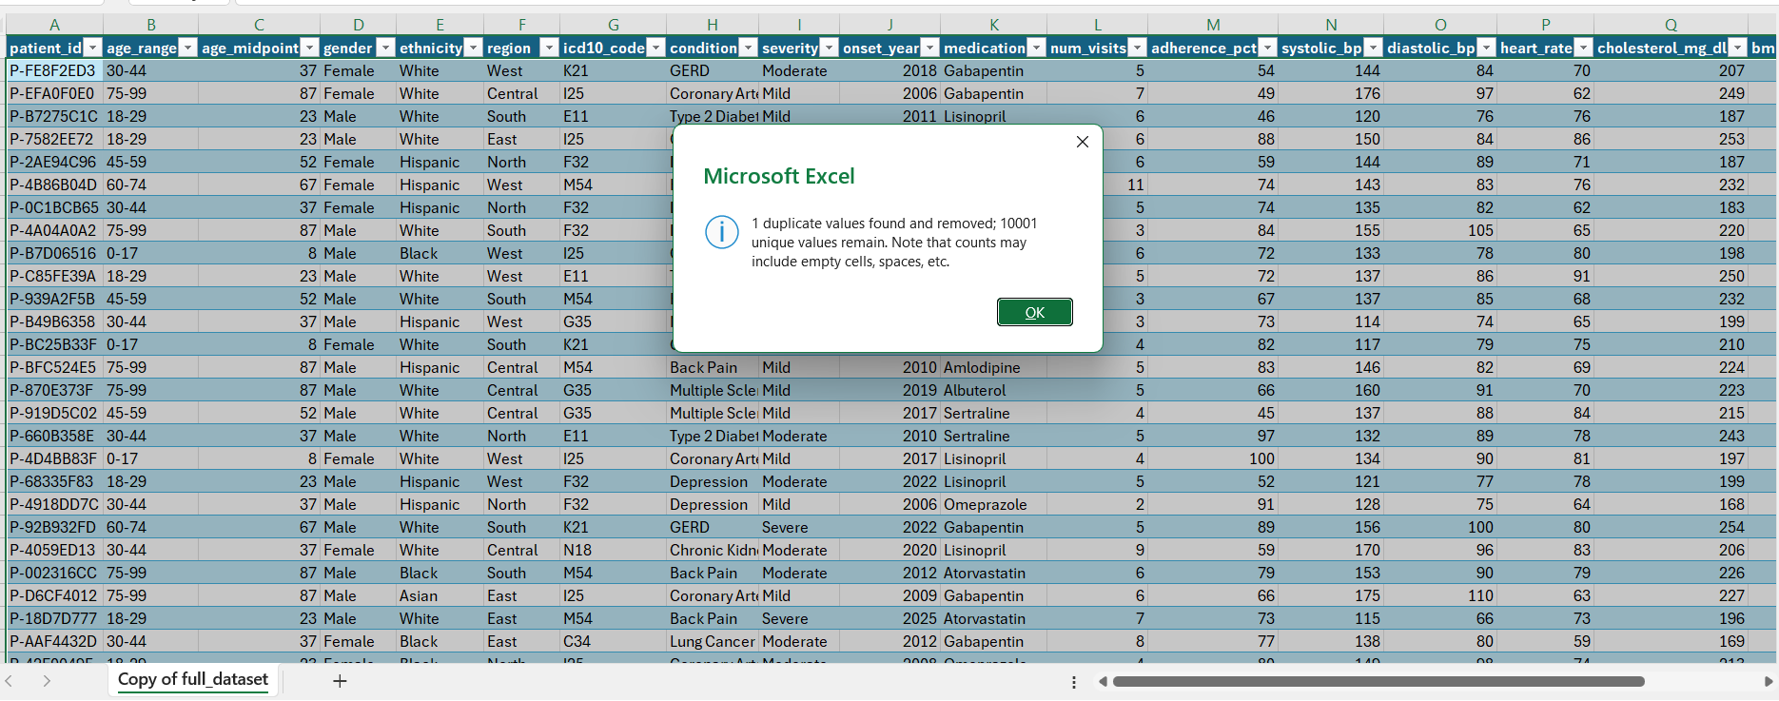
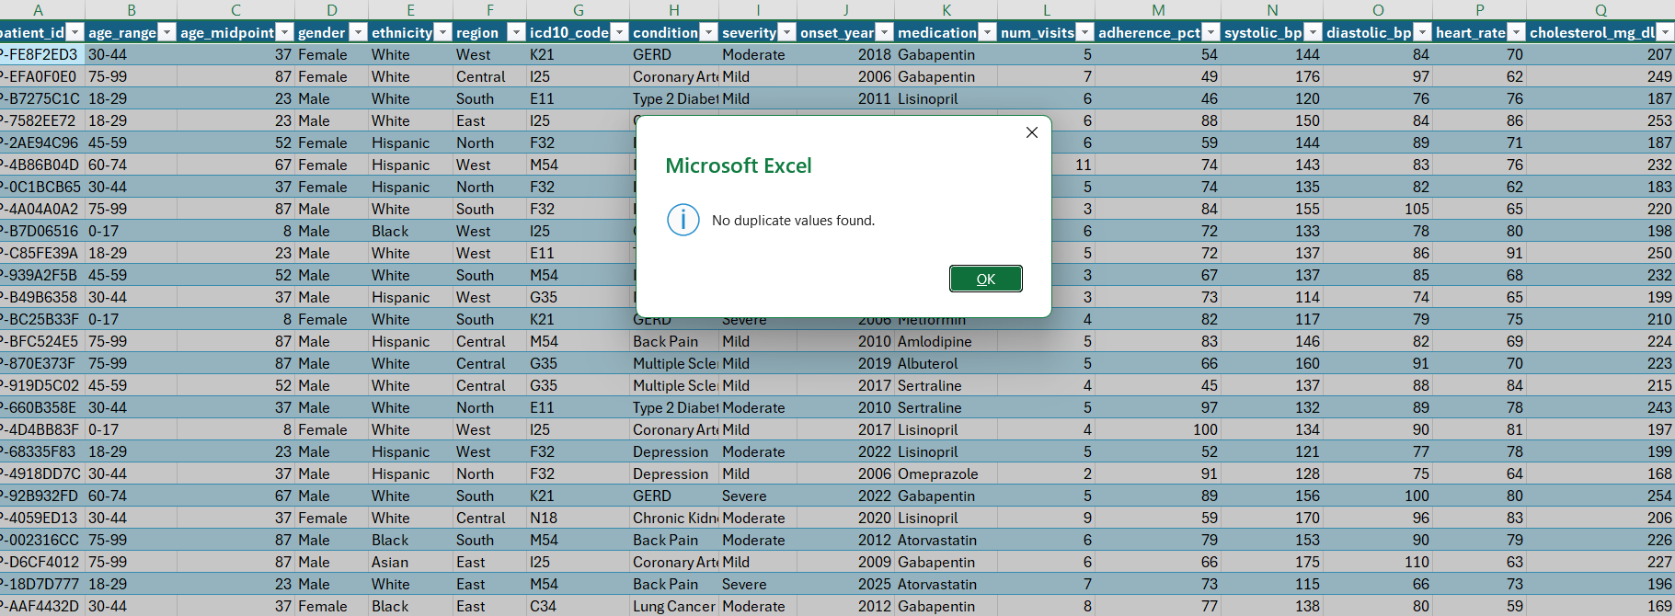
TASKS PERFORMED:
- Data Cleaning & Transformation: Removed duplicates, handled missing values, standardized formats, and created calculated fields.
- Filtering & Sorting: Organized data to focus on relevant records.
- Pivot Tables: Generated Pivot Tables for data summarisation and initial insights.
- Convert the data into Fact and Dimension Table (If Possible)
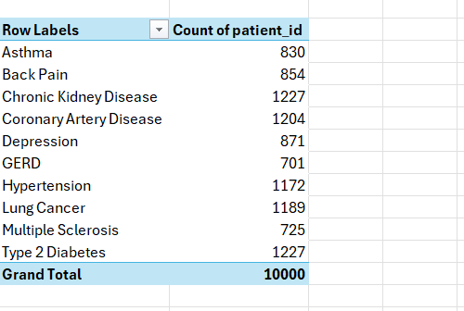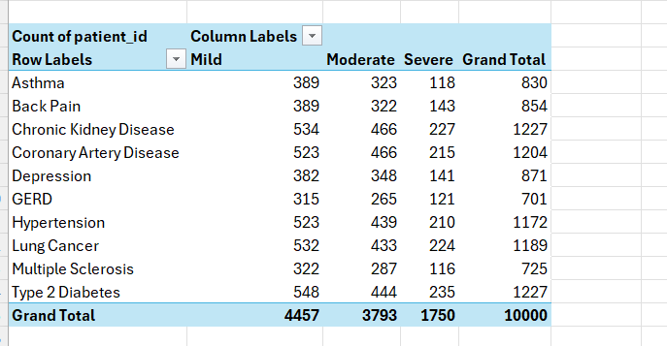
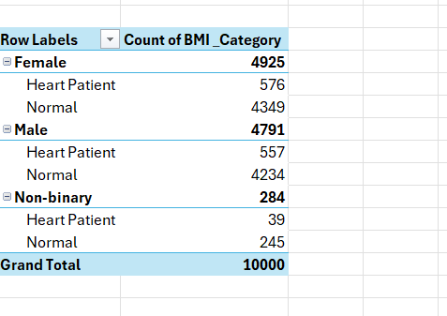
DATA MODELLING AND DAX:
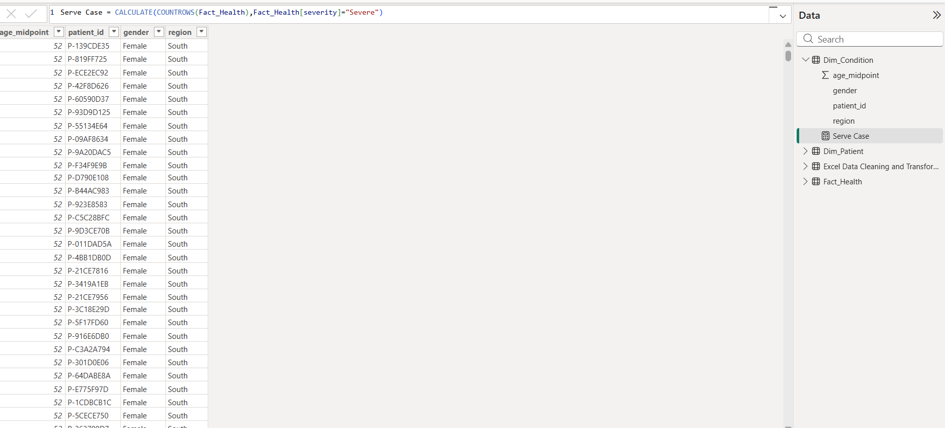
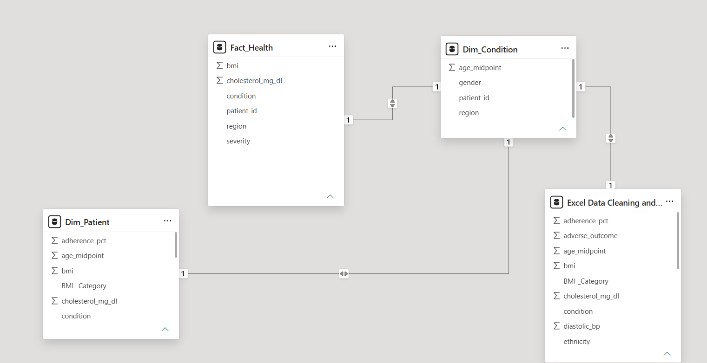
MalePatients=CALCULATE(DISTINCTCOUNT(Fact_Health[Patient_id]),Dim_Patient[gender]=”Male”)
FemalePatients=CALCULATE(DISTINCTCOUNT(Fact_Health[Patient_id]),Dim_Patient[gender]=”Female”)
Serve Cases=CALCULATE(COUNTROWS(Fact_Health),Fact_Health[severity]=”Serve”)
ANALYSIS AND VISUALIZATION (Power BI):
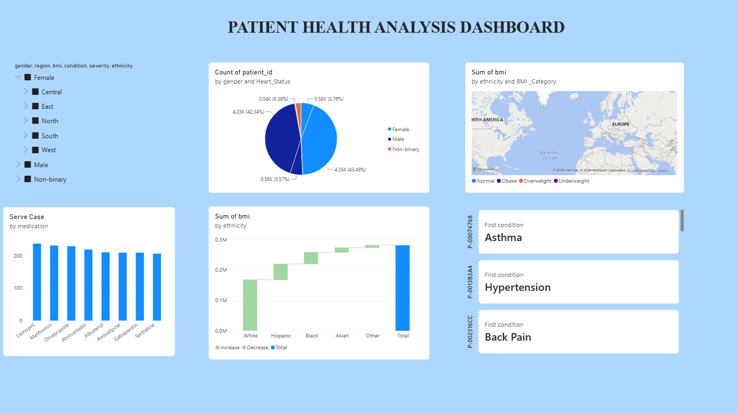
INSIGHTS :
1. Descriptive Analytics – What happened?
"First, I would like to explain the overall patient health analysis.
This dashboard gives an overview of patient details based on gender, region, BMI medical conditions, severity, and ethnicity.
From the gender analysis, we can understand the distribution of patients across different gender categories and heart status.
The medication chart shows that Lisinopril has the highest number of cases, while Sertraline has the lowest among the displayed medications.
The dashboard also highlights some patient conditions, such as Asthma, Hypertension, and Back Pain."
2. Diagnostic Analytics – Why did it happen?
"Next, I move to diagnostic analytics.
Here, I analyse why certain health patterns may occur.
By comparing BMI across different ethnic groups, we can understand how BMI values vary between groups.
Similarly, by analysing medication usage, we can identify which medications are more frequently used.
This helps us understand the patterns in patient health data."
3. Predictive Analytics – What might happen?
"Moving on to predictive analytics.
Based on historical patient data, we can predict possible future health trends.
For example, patients with higher BMI values may need closer health monitoring.
We can also use previous medical records to identify patients who may be at risk of developing certain health conditions.
These are predictions that would require a suitable forecasting or machine learning mode
4. Prescriptive Analytics – What should we do?
"Finally, prescriptive analytics.
Based on the analysis, healthcare providers can take appropriate decisions.
For example, they can recommend regular health check-ups, encourage patients to maintain a healthy BMI, and provide proper medication guidance.
They can also focus on patients who need additional medical attention.
This helps improve patient care and healthcare management."
CONCLUSION:
"Overall, this dashboard helps us understand patient health information through different perspectives.
Descriptive analytics explains what happened, diagnostic analytics explains why it happened, predictive analytics estimates what might happen next, and prescriptive analytics suggests what actions should be taken.
By using these four types of analytics, healthcare providers can make better data-driven decisions and improve patient care."

